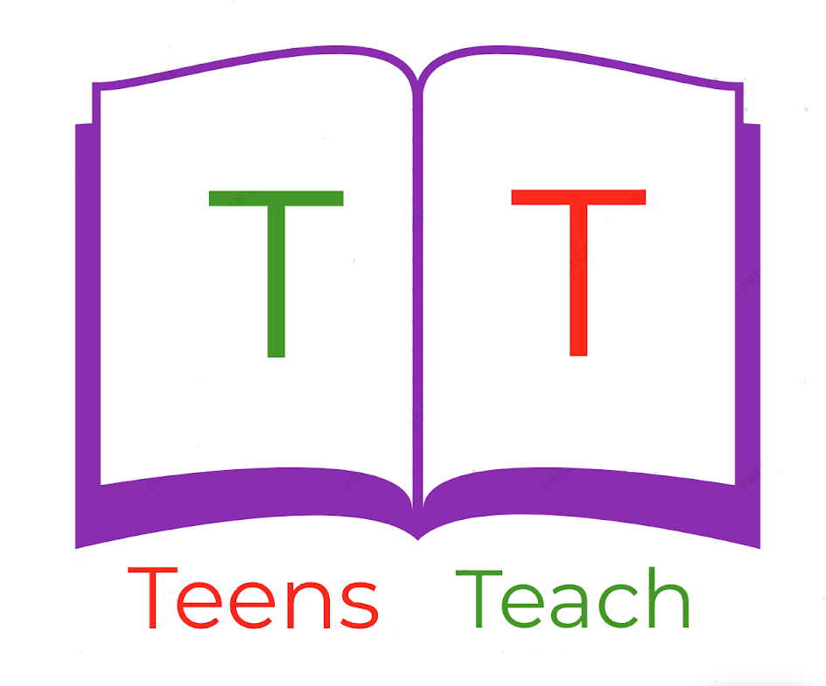
Jugendliche unterrichten Deutsch und mehr

Describe the following parts of the body:

- Nose:

________________________________________________________________________

________________________________________________________________________

- Hands:

________________________________________________________________________

________________________________________________________________________

- Ears:

________________________________________________________________________

________________________________________________________________________

- Toes:

________________________________________________________________________

________________________________________________________________________

- Mouth:

________________________________________________________________________

________________________________________________________________________

- Hair:

________________________________________________________________________

________________________________________________________________________

