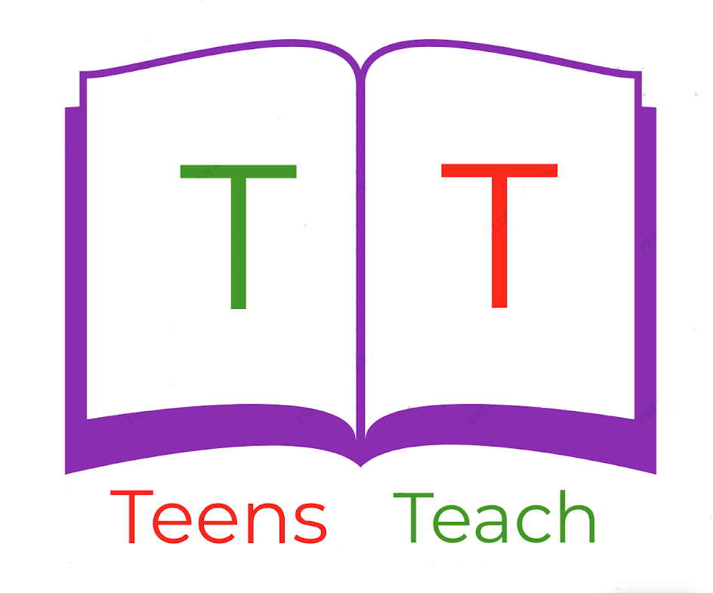
Jugendliche unterrichten Deutsch und mehr

Write a story about a park:
Use these topics as guiding questions:

What items do you find in a park?
Who is in the park?
What are people doing in the park?

______________________________________________________________________________

______________________________________________________________________________

______________________________________________________________________________

______________________________________________________________________________

______________________________________________________________________________

______________________________________________________________________________

______________________________________________________________________________

______________________________________________________________________________

______________________________________________________________________________

