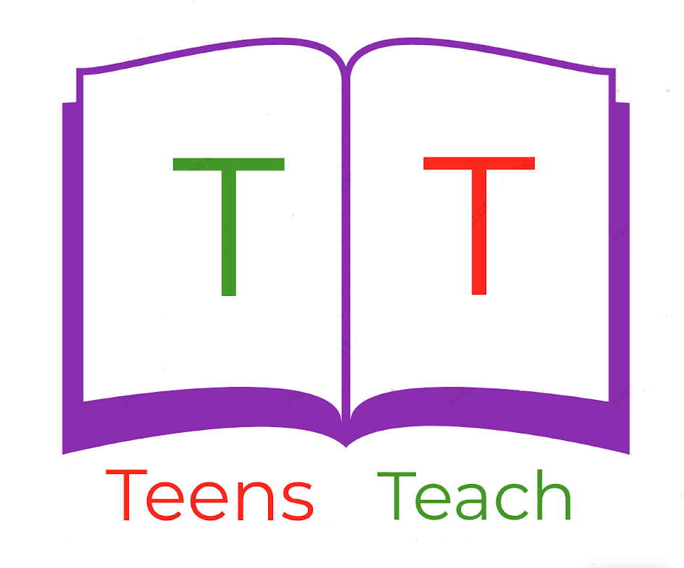
Jugendliche unterrichten Deutsch und mehr

Using the verb “to like”

I like We like

You like You (pl) like

He/she/it likes They like

- We _______ fruit.

- He _____________ (like) _____________ (eat) chocolate. (präsens/present)

- They _____________ (like) _____________ (play) football. (präsens/present)

- Emily and Lia _____________ (like) _____________ (travel). (präsens/present)

- I _____________ the summer last year.

- She _____________ the sun last week.

Write two sentences using the verb “to like”:
- ________________________________________________________________________________________________________________________________________________

- ________________________________________________________________________________________________________________________________________________

