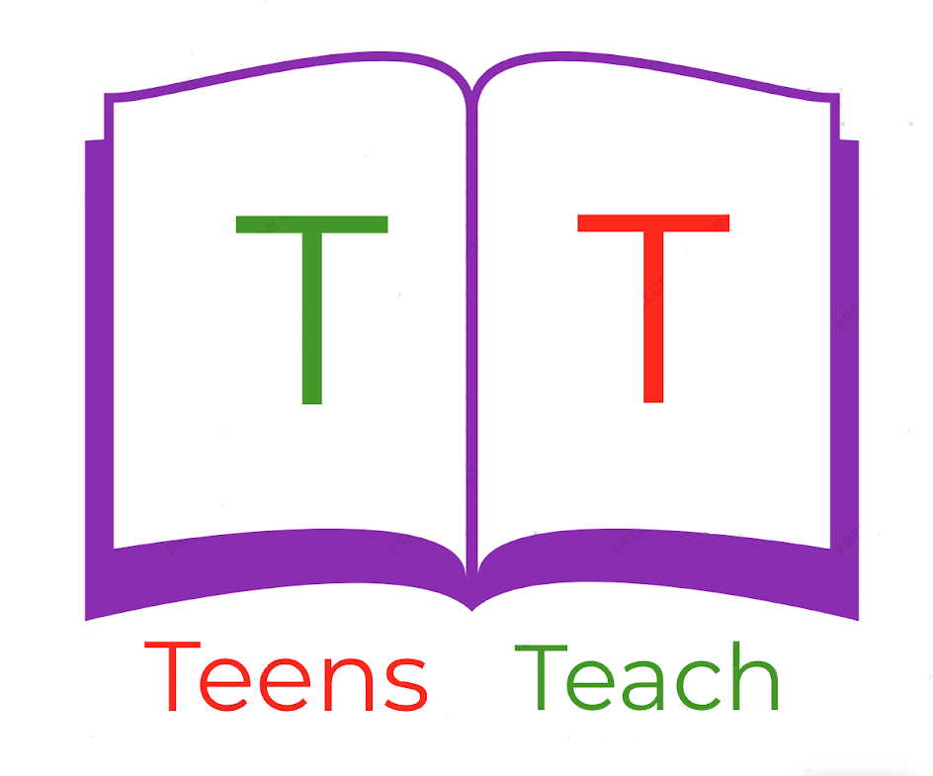
Jugendliche unterrichten Deutsch und mehr
Fill in the blanks:

1. Active: I was buying a cake.

Passive: _____________________

2. Active: _____________________

Passive: The house was sold by you.

3. Active: We were sleeping on the bed.

Passive: _____________________

4. Active: They were sitting on the chairs.

Passive: _____________________

5. Active: You were taking the picture.

Passive: _____________________

6. Active: I was eating the fruit

Passive: _____________________

7. Active: _____________________

Passive: The ball was thrown by us.

8. Active: The warrior was attacking the castle

Passive: _____________________

