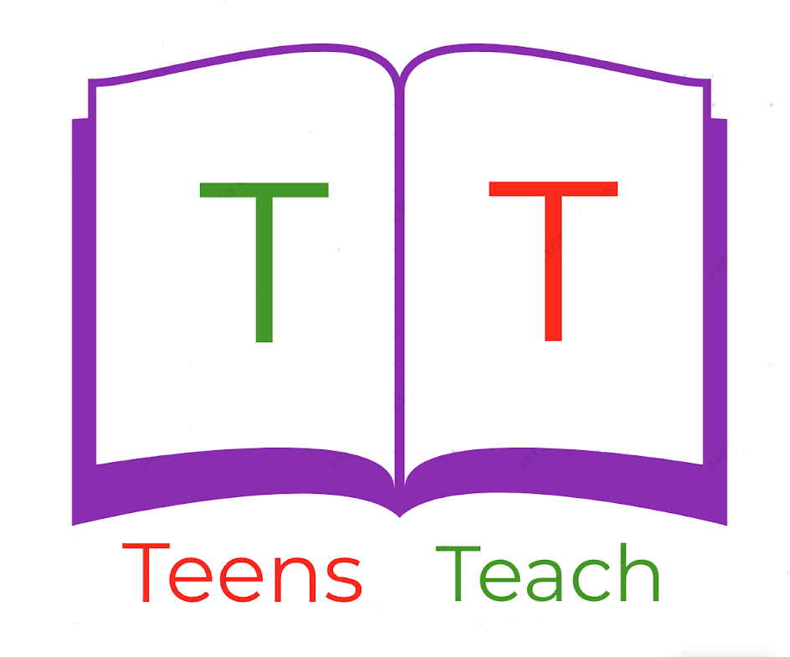
Jugendliche unterrichten Deutsch und mehr
Fill in the blanks:

1. Active: You are buying the apple.

Passive: _____________________

2. Active: _____________________

Passive: The chair is being bought by him.

3. Active: She is sleeping on the pillow.

Passive: _____________________

4. Active: They are watching TV.

Passive: _____________________

5. Active: I am sitting on the chair.

Passive: _____________________

6. Active: You are breaking the bed.

Passive: _____________________

7. Active: _____________________

Passive: The milk is being drunk by them.

8. Active: The baker is baking the bread.

Passive: _____________________

