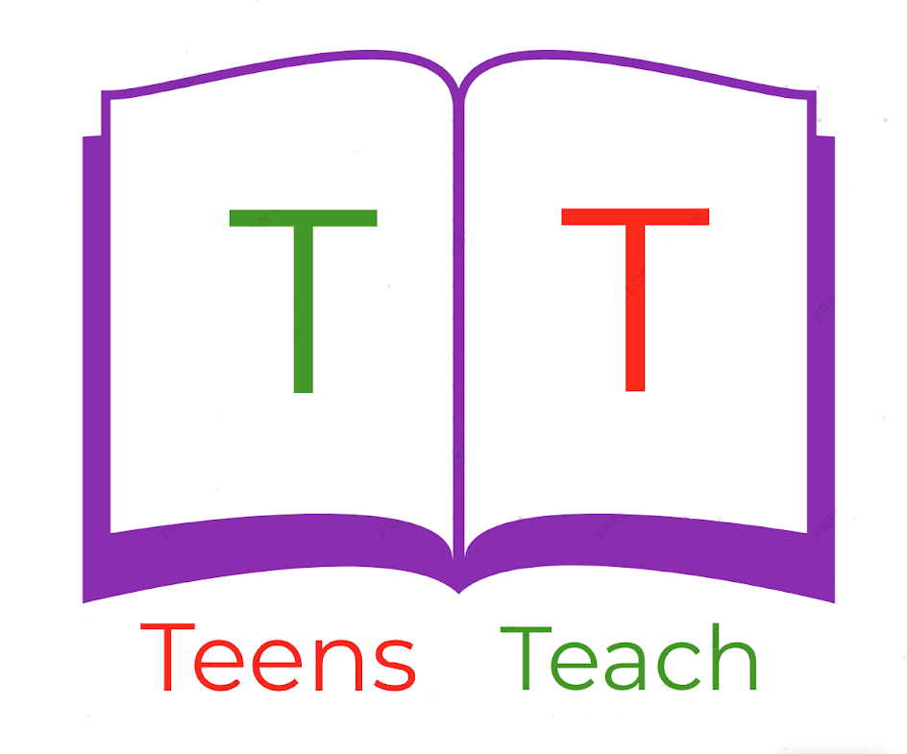
Jugendliche unterrichten Deutsch und mehr
Build a proper sentence:
Beispiel: (I)(to try)(apple)(to eat)
I try to eat an apple.
- (I)(to try)(banana)(to eat)

_____________________________________________________________________

- (We)(to try)(car)(to drive)

_____________________________________________________________________

- (You)(to try)(book)(to read)

_____________________________________________________________________

- (He)(to try)(homework)(to do)

_____________________________________________________________________

- (We)(to try)(photo)(to take)

_____________________________________________________________________

- (They)(to try)(to)(English course)(to go)

_____________________________________________________________________

- (I)(to try)(to)(University)(to go)

_____________________________________________________________________

- (We)(to try)(on)(bed)(to sleep)

_____________________________________________________________________

- (You)(to try)(lamp)(to turn on)

_____________________________________________________________________

