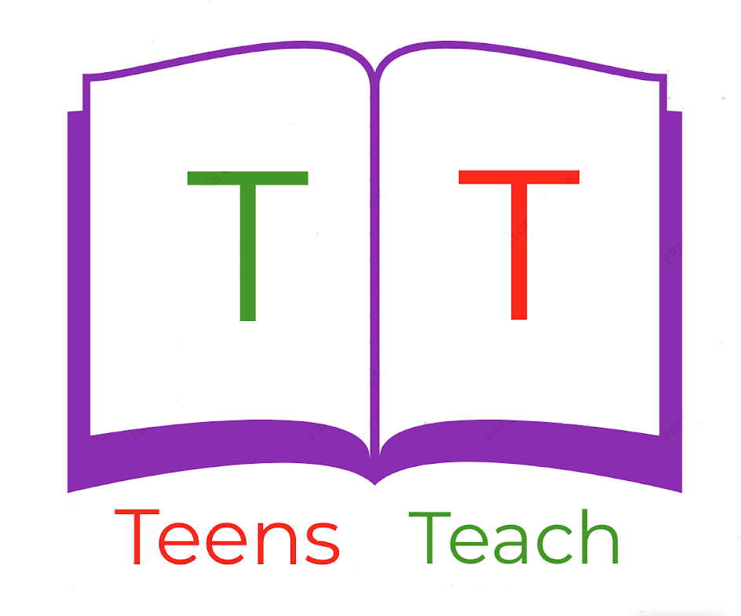
Jugendliche unterrichten Deutsch und mehr

1. ______________  3. ______________  5. ______________  7. ______________  9. ______________ | 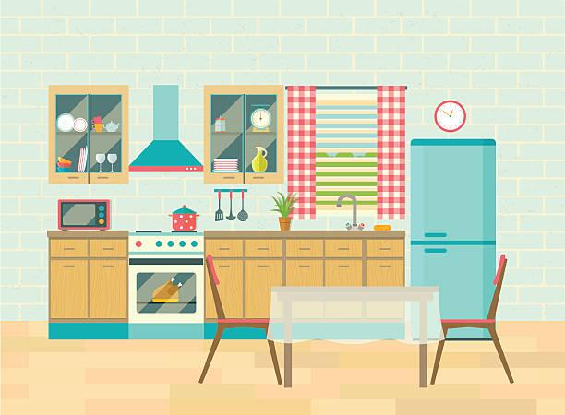 | 2. ______________  4. ______________  6. ______________  8. ______________  10. _____________

Fill in the labels with vocabulary in the wordbox below and draw an arrow connecting it to the appropriate location:

chair, tablecloth, cup, oven, refrigerator, microwave, sink, plate, clock, plant

