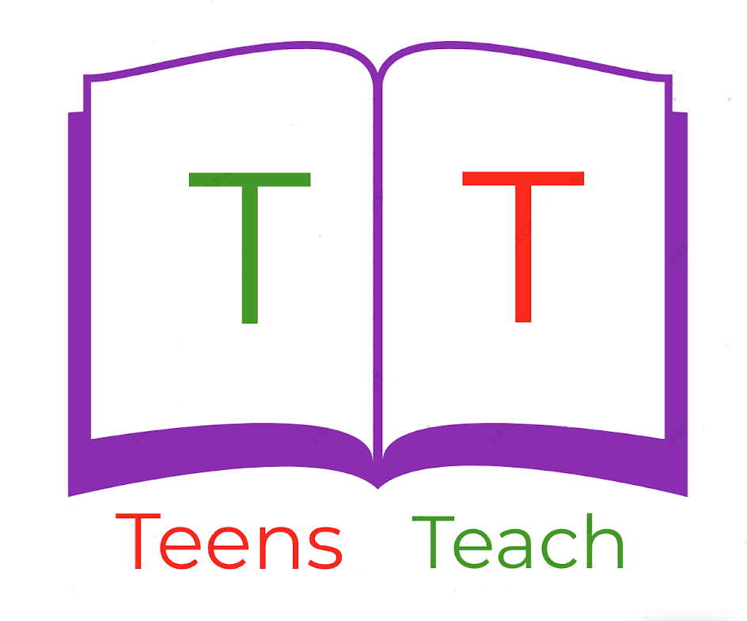
Jugendliche unterrichten Deutsch und mehr

1. ______________  3. ______________  5. ______________  7. ______________  9. ______________ |  | 2. _____________  4. _____________  6. _____________  8. _____________  10. ____________

Fill in the labels with vocabulary in the wordbox below and draw an arrow connecting it to the appropriate location:

dog, leash, tree, path, field, bench, flower, athlete, grass, cloud

