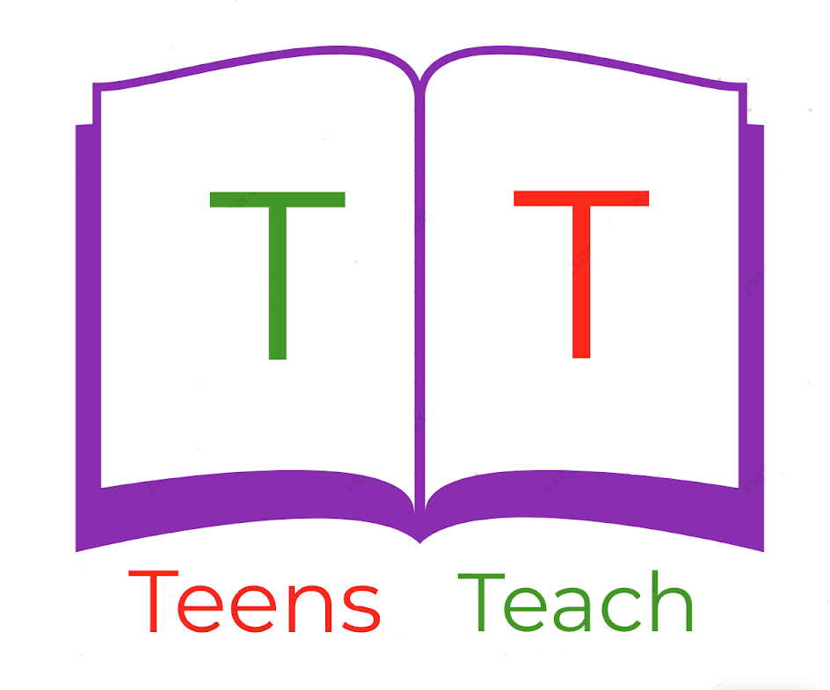
Jugendliche unterrichten Deutsch und mehr

Fill in the blanks with the indicated verb in the progressive form:
Fülle die Felder mit dem angegebenen Verb in der progressiven Form:

Bill ______________ (play) football.  We ______________ (write) at school.  I ______________ (talk) to my mother.  The rain ______________ (fall).  My brother ______________ (practice) guitar.  They ______________ (run) to class.  You ______________ (sing) a song. | Neuen Worte  I sing - ich singe Rain - Regen  Song - Lied I practice - ich übe  Guitar - Gitarre

