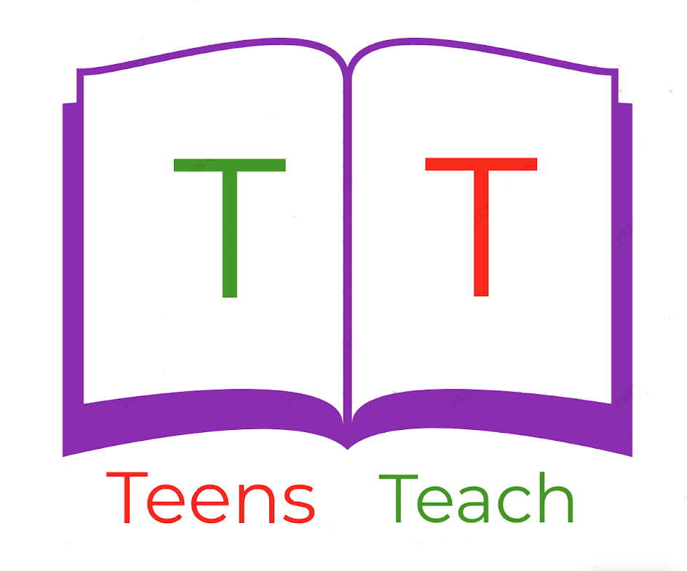
Jugendliche unterrichten Deutsch und mehr

1. ______________  3. ______________  5. ______________  7. ______________ |  | 2. _____________  4. _____________  6. _____________  8. _____________

Fill in the labels with vocabulary in the wordbox below and draw an arrow connecting it to the appropriate location:

sun, birds, flower, path, tree, pine tree, grass, bench, cloud

