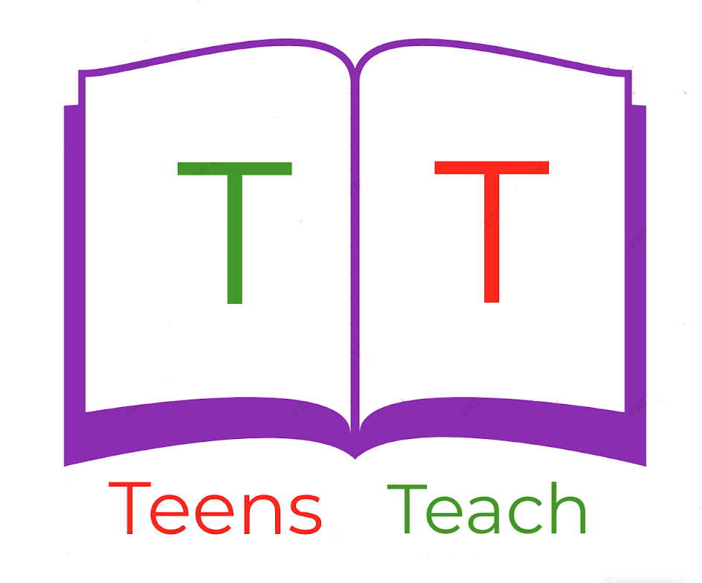
Jugendliche unterrichten Deutsch und mehr

R the labels below and answer the questions on the following page:
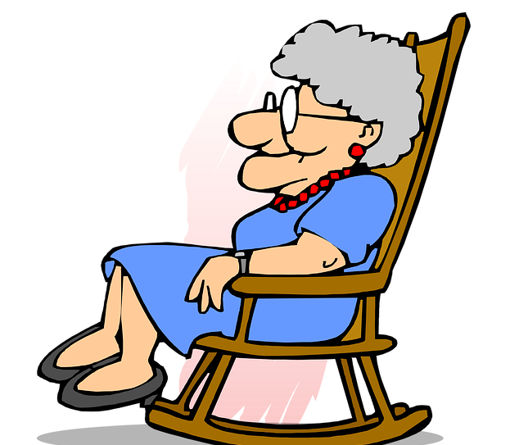  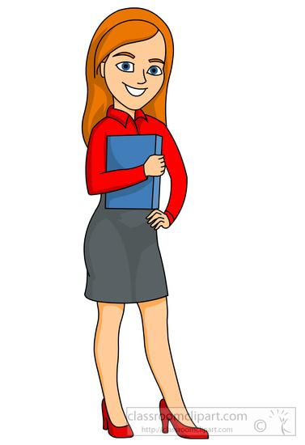 | Paula  John  Eric  Diane  Dyland  Maria

What is the name of the grandmother?

The grandmother is called Paula

What is the name of the grandfather?

What is the name of the son?

What is the name of the mother?

What is the name of the daughter?

What is the name of the father?

