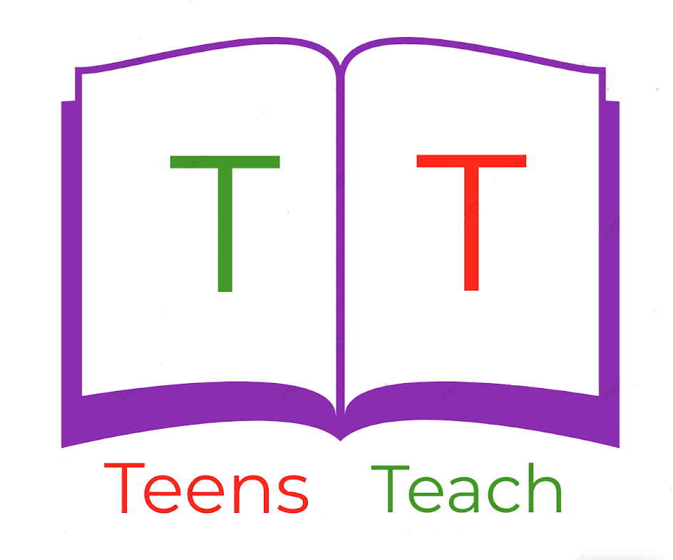
Jugendliche unterrichten Deutsch und mehr
1. ______________  3. ______________  5. ______________ | 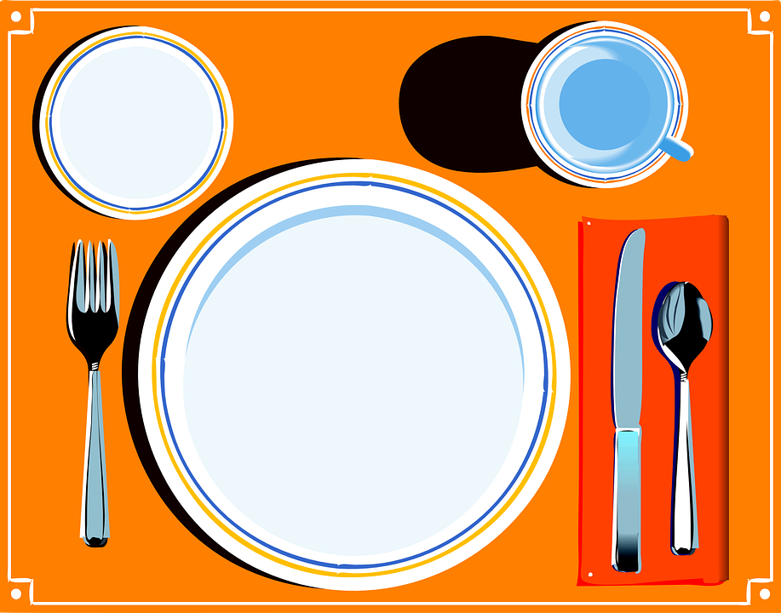 | 2. _____________  4. _____________  6. _____________

Fill in the labels with vocabulary in the wordbox below and draw an arrow connecting it to the appropriate location:

Fork, Knife, Spoon, Plate, Cup, Napkin

