Jugendliche unterrichten Deutsch und mehr

1. ______________  3. ______________  5. ______________ | 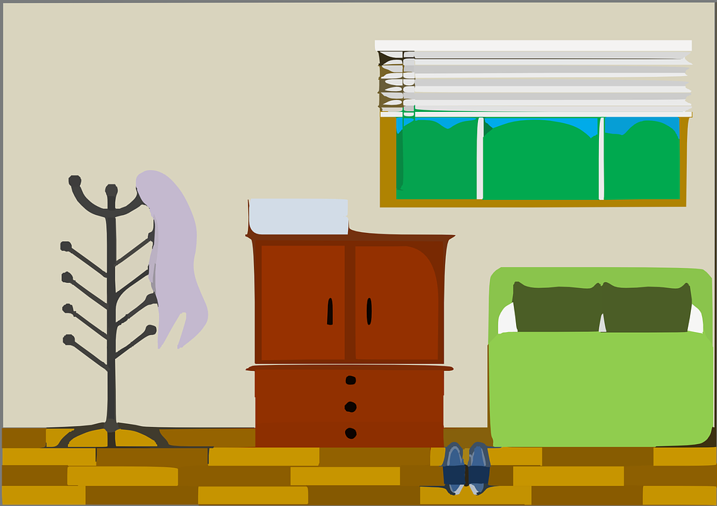 | 2. ______________  4. ______________

Fill in the labels with vocabulary in the wordbox below and draw an arrow connecting it to the appropriate location:

shoes, closet, window, couch, coat hanger

