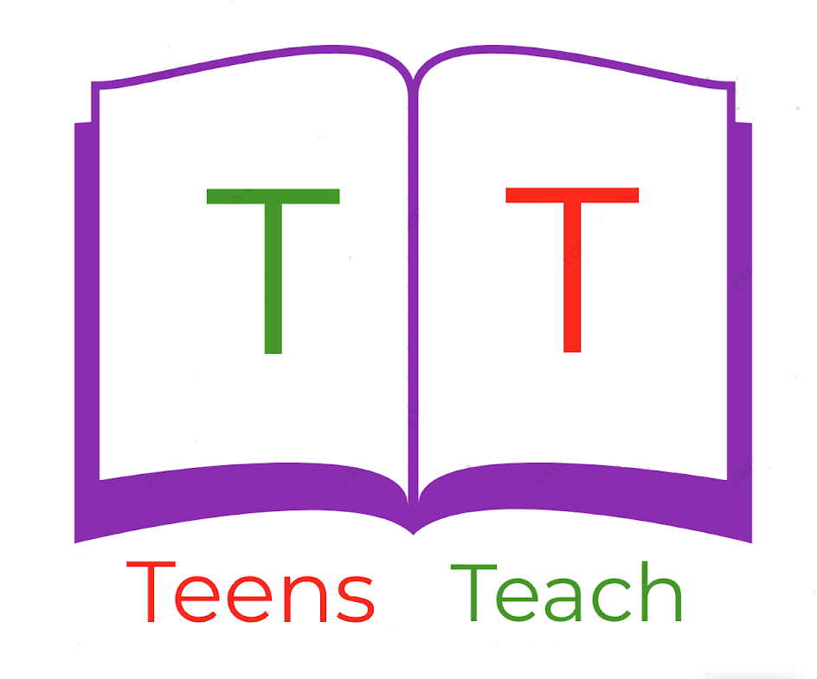

Jugendliche unterrichten Deutsch und mehr

Connect the word with the appropriate picture:

|  |  |
| --- | --- |
| Image result for girl clipart | a. Father |
| Image result for grandmother cartoon | b. Son |
| Related image | c. Grandmother |
| Image result for father clipart | d. Grandfather |
| Image result for grandfather clipart | e. Family |
| Image result for boy clipart | f. Girl |
| Image result for mother clipart | g. Mother and daughter |