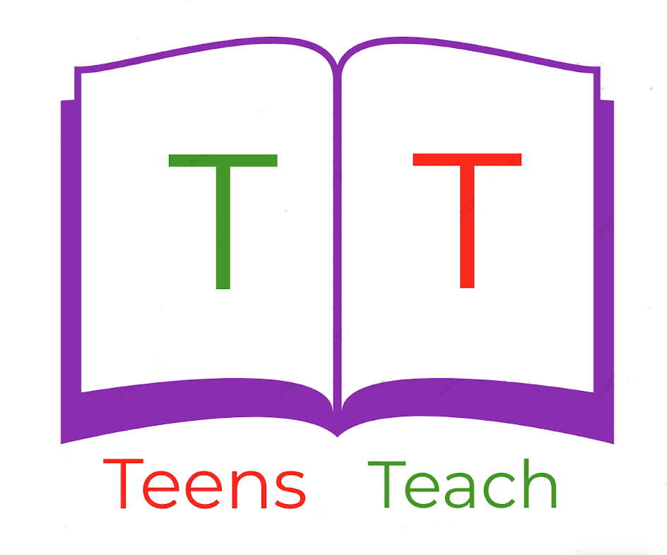

Jugendliche unterrichten Deutsch und mehr

|  |  |  |
| --- | --- | --- |
| Zahl (1,2,3…) | Zahl ausgeschrieben (eins, zwei, drei…) |  |
|  | 2.  3.  4.  5.  6. | 1. Image result for clipart fruitImage result for clipart fruitImage result for clipart fruit 2. Image result for clipart fruitImage result for clipart fruitImage result for clipart fruitImage result for clipart fruit 3. Image result for clipart fruit 4. Image result for clipart fruitImage result for clipart fruitImage result for clipart fruitImage result for clipart fruitImage result for clipart fruitImage result for clipart fruit 5. Image result for clipart fruitImage result for clipart fruitImage result for clipart fruitImage result for clipart fruitImage result for clipart fruit 6. Image result for clipart fruitImage result for clipart fruitImage result for clipart fruitImage result for clipart fruitImage result for clipart fruitImage result for clipart fruitImage result for clipart fruit |