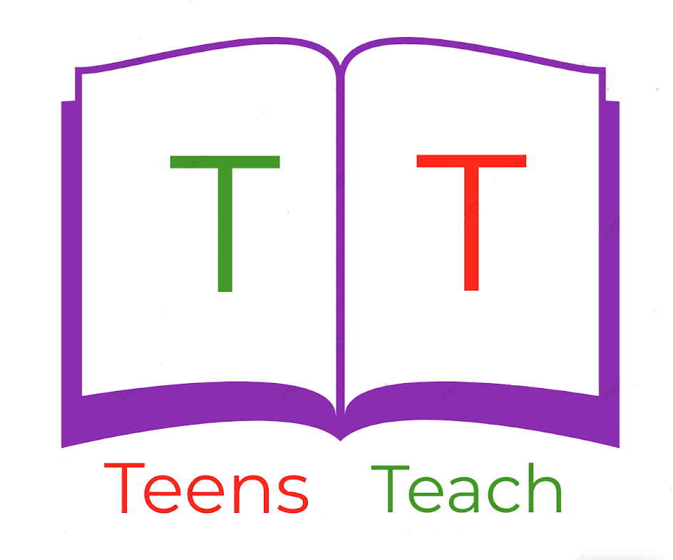
Jugendliche unterrichten Deutsch und mehr

Beschreibe die folgenden Körperteile:

- Nase:

________________________________________________________________________

________________________________________________________________________

- Hände:

________________________________________________________________________

________________________________________________________________________

- Ohren:

________________________________________________________________________

________________________________________________________________________

- Zehen:

________________________________________________________________________

________________________________________________________________________

- Mund:

________________________________________________________________________

________________________________________________________________________

- Haare:

________________________________________________________________________

________________________________________________________________________

