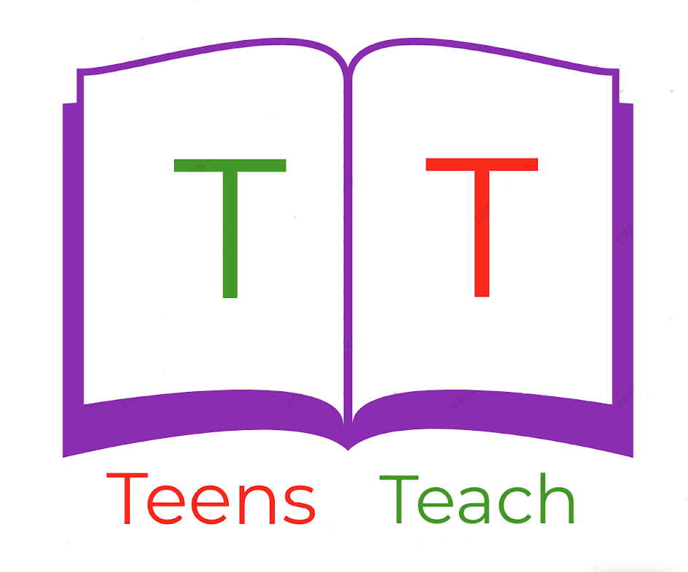
Jugendliche unterrichten Deutsch und mehr

Buchstaben Nachzeichnen:

A...a...A...a.........................................................................................................
B...b...B...b.........................................................................................................
C...c...C...c..........................................................................................................
D...d...D...d.........................................................................................................
E...e...E...e..........................................................................................................
F...f...F...f...........................................................................................................
G...g...G...g.........................................................................................................
H...h...H...h.........................................................................................................
I...i...I...i..............................................................................................................
J...j...J...j.............................................................................................................
K...k...K...k.........................................................................................................
L...l...L...l...........................................................................................................
M...m...M...m.....................................................................................................
N...n...N...n.........................................................................................................
O...o...O...o.........................................................................................................
P...p...P...p..........................................................................................................
Q...q...Q...q.........................................................................................................
R...r...R...r...........................................................................................................
S...s...S...s...........................................................................................................
T...t...T...t...........................................................................................................
U...u...U...u.........................................................................................................
V...v...V...v.........................................................................................................
W...w...W...w.....................................................................................................
X...x...X...x.........................................................................................................
Y...y...Y...y.........................................................................................................
Z...z...Z...z..........................................................................................................
Ä...ä...Ä...ä.........................................................................................................
Ö...ö...Ö...ö.........................................................................................................
Ü...ü...Ü...ü.........................................................................................................
ß...ß...ß...ß...........................................................................................................

