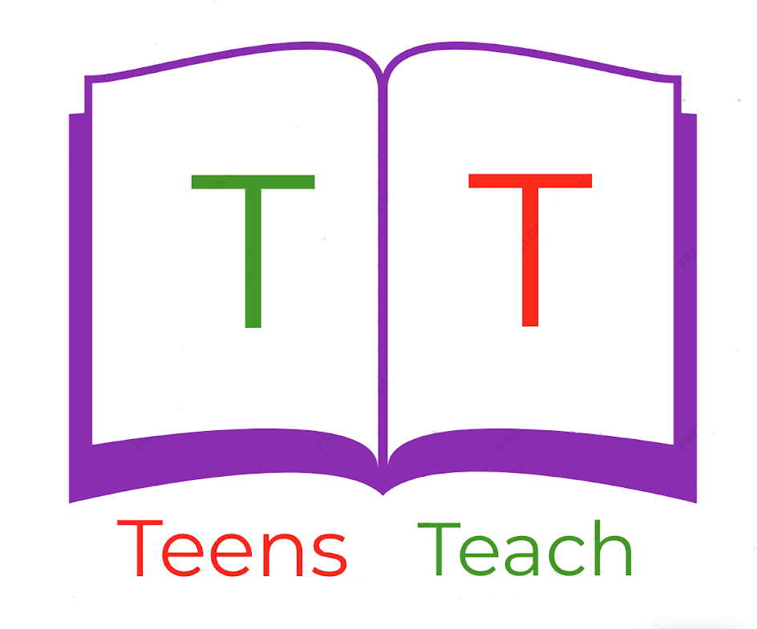
Jugendliche unterrichten Deutsch und mehr

Read and respond to the following letter:

Dear Anna,

Hopefully you’re doing well! How is it in Germany? How's it going at school? I was hiking with my family last week. The view was amazing and the air was great. I have vacation in two weeks. When do you have vacation? Would you like to go hiking during the summer holidays? That would be lots of fun. Let me know what your plans are!

Your friend,

Max

Dear Max,

____________________________________________________________________________

____________________________________________________________________________

____________________________________________________________________________

____________________________________________________________________________

____________________________________________________________________________

____________________________________________________________________________

____________________________________________________________________________

____________________________________________________________________________

____________________________________________________________________________

