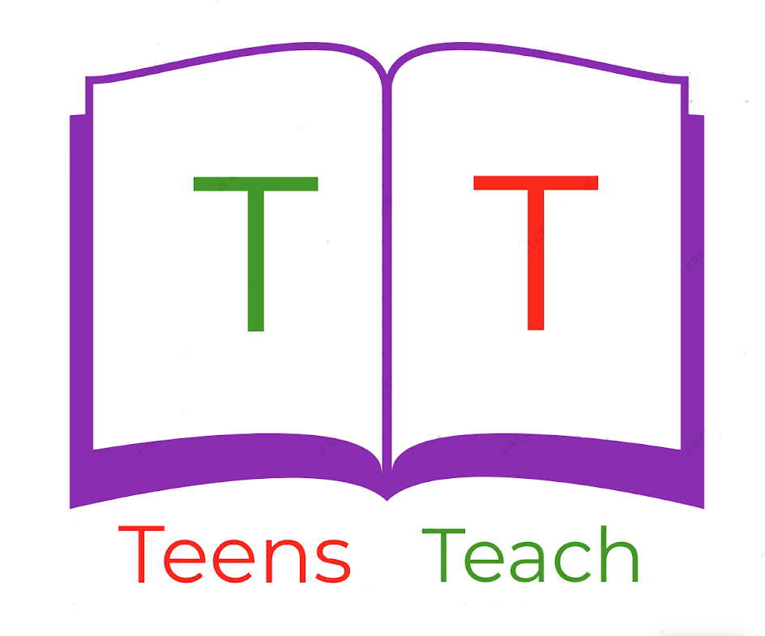
Jugendliche unterrichten Deutsch und mehr
Fill in the blanks:

1. Active: I am buying a cake.

Passive: _____________________

2. Active: _____________________

Passive: The house is being sold by you.

3. Active: We are sleeping on the bed.

Passive: _____________________

4. Active: They are sitting on the chairs.

Passive: _____________________

5. Active: You are taking the picture.

Passive: _____________________

6. Active: I am eating the fruit

Passive: _____________________

7. Active: _____________________

Passive: The ball is being thrown by us.

8. Active: The warrior is attacking the castle

Passive: _____________________

