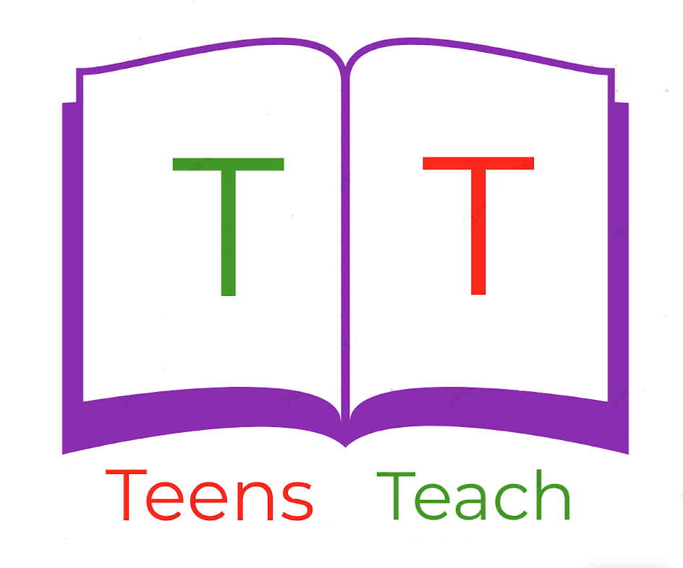

Jugendliche unterrichten Deutsch und mehr

Connect the word with the appropriate picture:

|  |  |
| --- | --- |
| 1. Grandfather _____ 2. Daughter _____ 3. Mother _____ 4. Father _____ 5. Son _____ | 1. Image result for woman cartoon 2. Image result for boy cartoon 3. Image result for father image 4. Image result for grandfather cartoon 5. Image result for girl cartoon |